Virginia Child Count Dec 2023*
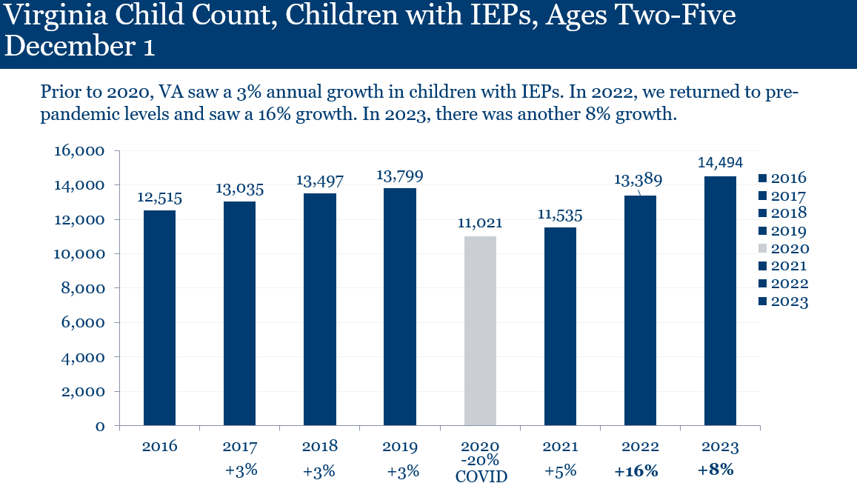
Children with IEPs, Ages 2-5
- In 2015, 12,111 children
- In 2016, 12,515 children
- In 2017, 13,035 children
- In 2018, 13,497 children
- In 2019, 13,799 children
- In 2020 (Covid-19), 11,021 children (2020 total decreased of 2,778, 20%)
- In 2021, 11,535 children (2021 total decrease of 2,264 from 2019, 16%)*
*Prior years were increasing by 3%
- In 2022, 13,389 children (16% increase from 2021)
- In 2023, 14,494 children (8% increase from 2022)
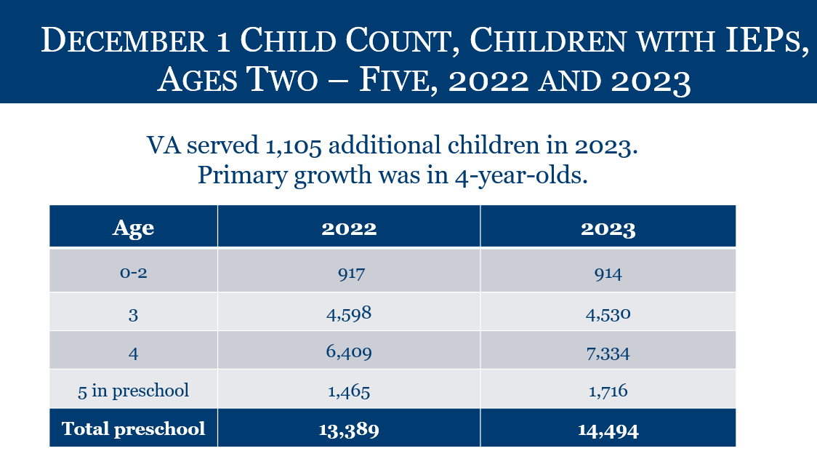
Children with IEPs, by Age
- Ages 0-2: 914 children with IEPs
- Age 3: 4,530 children with IEPs
- Age 4: 7,334 children with IEPs
- Age 5: 1,716 children with IEPs
- TOTAL PRESCHOOL: 14,494 children with IEPs

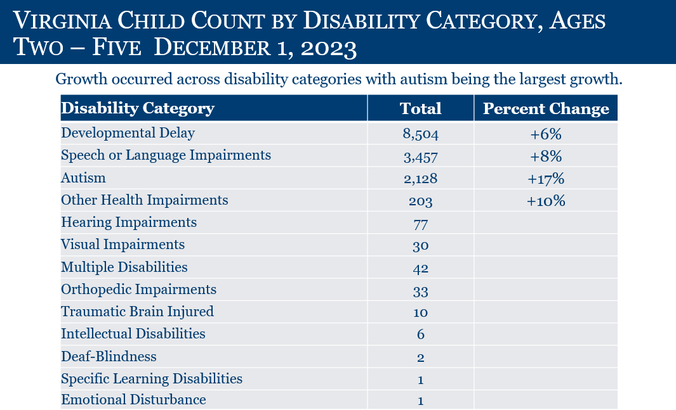
2-5 Year Olds (TOTAL: 14,494)
Developmental Delay: 8,504 (+6%)
Speech Language Impairment: 3,457 (+8%)
Autism: 2,128 (+17%)
Other Health Impairments: 203 (+10%)
Hearing Impairments: 77
Visual Impairment: 30
Multiple Disabilities: 42
Orthopedic Impairment: 33
Traumatic Brain Injured: 10
Intellectual Disability: 6
Deaf-Blindness: 2
Specific Learning Disability: 1
Emotional Disturbance: 1

*This is preliminary data and will be reviewed and confirmed by the Virginia Department of Education (VDOE) and Office of Special Education Programs.

