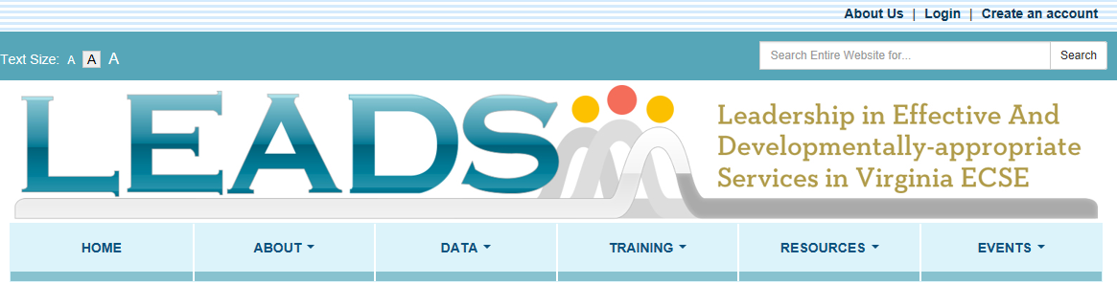
WEBSITE OVERVIEW

HOME
Create an Account – in top right corner and in a box below CCSS box next to My Toolbox. Create an account to use My Toolbox to tag favorite links, track webshops, store certificates from the webshops, and gain access to the information exchange.
Log in – after one creates an account, it is best to always login upon entry. Login is in the top right corner. If you do not log in, you cannot save items to “My Toolbox”
Check it out - information will be changed periodically to highlight specific additions to the website or other pertinent information.
Alert box – this is the section across the top of the home page to alert/inform people about specific updates and availability of specific information, similar to an “announcements” section
TTAC map - can be clicked on to find TTAC contact information.
Creating Connections to Shining Stars box - provides easy access to CCSS information as it links to the CCSS page. Look here for links to call for proposals, registration, etc.
My Toolbox – when a user creates an account, the user can then store favorite links in the toolbox. Webshops they have started will also be stored in the toolbox along with certificates of completions for the webshops provided through the LEADS website.
Search box – an option to search the entire website is located in the top right corner

ABOUT
The text on the about page includes information about the purpose and goals of LEADS, the website, and the ECSE Network. There is also a link to the ECSE Network Scope of Work on this page. FAQs will change as developed.

ABOUT
LEADS information
VDOE TTAC ECSE Contacts
FAQs
My Toolbox
Contact Us

DATA

DATA
Importance of Data
Indicator 6
Resources
Information Exchange
State Data
Indicator 7
Resources
Information Exchange
State Data
Indicator 12
Resources
Information Exchange
State Data
Other
Resources
Information Exchange
State Data

The data area provides an overview of the importance of data in early childhood and draws connections of data to SSIP, SIMR, and early childhood connections to graduation. The menu divides by specific indicators and other with all having the same sub-menu of resources, information exchange, and state data. The resources included will be specific to the Indicator data tab of that section. The information exchange area is used to collection information from LEADS members about specific data-related topics. The information will be collected and shared back out to LEADS members through the website. All information posted must first be approved by the LEADS coordinator before it will be visible on the website. The state data area provides state-level data so that it can be used as a reference point and in professional development. Please note that you must create an account to access the information exchange area of the LEADS website.

TRAINING
TRAINING
Leadership
Webshops & eWorkshops
Indicator 6
Indicator 7
Indicator 12
Assessment
Child Development
Curriculum & Instruction
Family Involvement
Inclusion
Transition
Service Providers
Webshops & eWorkshops
Indicator 6
Indicator 7
Indicator 12
Assessment
Child Development
Curriculum & Instruction
Family Involvement
Inclusion
Transition

The training page is divided into Leadership and Service providers and under both are Webshops & eWorkshops as a topic list for trainings. The webshops are specific training webinars created specifically for LEADS members. The eWorkshops is a series of related webshops. Once webshops or eWorkshops are posted, a person must have an account to access this area. The topical list provides links to relevant training offered by other organizations that relates to preschool data indicator topics. The links to the LEADS institutes handouts are stored under “Training:Leadership” The other trainings are categorized by Indicator 6, 7, or 12; assessment, child development, curriculum and instruction, family involvement, inclusion, and transition. There is a search feature available on the left for training.

RESOURCES

RESOURCES
Leadership
Research & Evidence Based Practices
Assessment
Child Development
Curriculum & Instruction
Family Involvement
Inclusion
Transition
Superintendent's Memos
Updates
Laws & Regulations
IDEA
ESSA
Policy guidance / statements
State/Federal Organizations
Service Provider
Research & Evidence Based Practices
Assessment
Child Development
Curriculum & Instruction
Family Involvement
Inclusion
Transition
Laws & Regulations
IDEA
ESSA
Policy guidance / statements
State/Federal Organizations

The drop down menu shows the categories in which resources are stored. There is a search feature available on the left. These resources are not necessarily data specific but will focus on topics that support data indicator topics, an ECSE knowledge base, program improvement, etc. While the area is split into Leadership and Service Provider, many of the same resources are located in both areas.

EVENTS

EVENTS
Leadership
State Events
National Events
Online Events
Regional Events
Archived Events
Calendar
Service Provider
State Events
National Events
Online Events
Regional Events
Archived Events
Calendar

The events area includes meetings, webinars, and other events that typically are offered on a specific date or timeframe. The topics are broader than what is included in the “training links” under the DATA tab and are stored in the topical areas identified in the drop down menu. There is a search feature available on the left. There is a calendar feature that allows you to see the events on a monthly calendar. Events that occurred will automatically move to Archived Events so that you can find the dates/times/titles of events, however, the event remains available only if the organization providing the event offers a recording or archive of the event.

