Virginia Child Count Dec 2022*
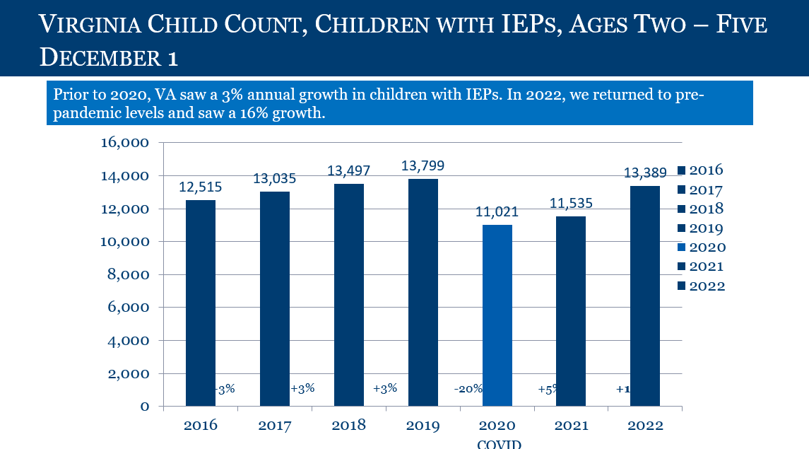
Children with IEPs, Ages 2-5
- In 2015, 12,111 children
- In 2016, 12,515 children
- In 2017, 13,035 children
- In 2018, 13,497 children
- In 2019, 13,799 children
- In 2020 (Covid-19), 11,021 children (2020 total decreased of 2,778, 20%)
- In 2021, 11,535 children (2021 total decrease of 2,264 from 2019, 16%)*
*Prior years were increasing by 3%
- In 2022, 13,389 children (16% increase from 2021)
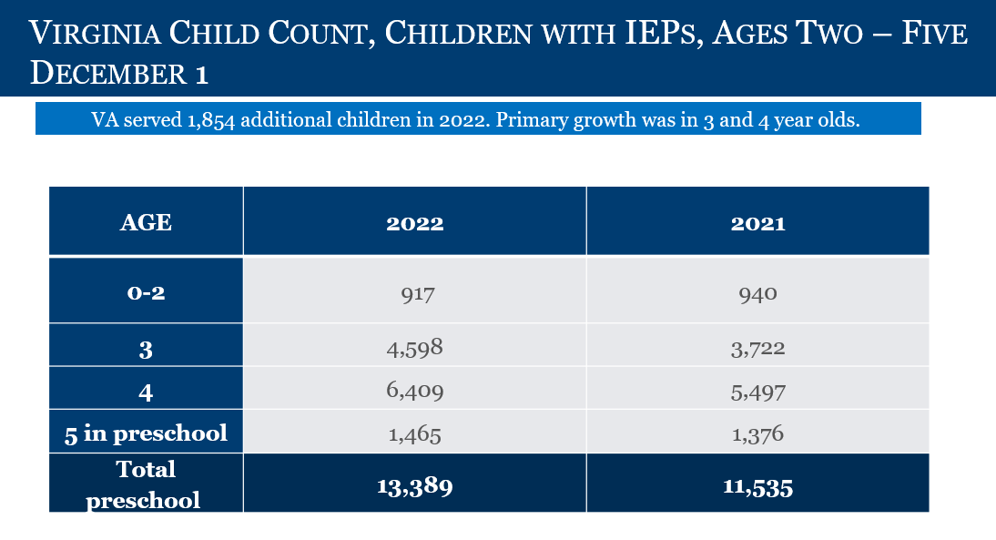
Children with IEPs, by Age
- Ages 0-2: 917 children with IEPs
- Age 3: 4,598 children with IEPs
- Age 4: 6,409 children with IEPs
- Age 5: 1,465 children with IEPs
- TOTAL PRESCHOOL: 13,389 children with IEPs

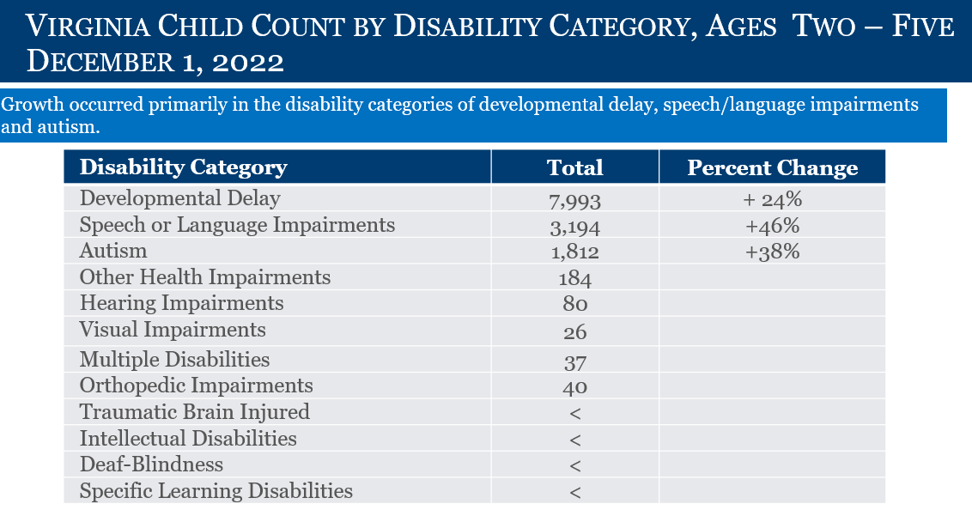
2-5 Year Olds (TOTAL: 13,389)
Developmental Delay: 7, 993 (+24%)
Speech Language Impairment: 3,194 (+46%)
Autism: 1,812 (+38%)
Other Health Impairments: 184
Hearing Impairments: 80
Visual Impairment: 26
Multiple Disabilities: 37
Orthopedic Impairment: 40
Traumatic Brain Injured: Number too low to report
Intellectual Disability: Number too low to report
Deaf-Blindness: Number too low to report
Specific Learning Disability: Number too low to report

*This is preliminary data and will be reviewed and confirmed by the Virginia Department of Education (VDOE) and Office of Special Education Programs.

