Supports for Young Children with Disabilities in Early Childhood (ages 2-5)

This resource is being provided to support preschool teachers of young children with disabilities. The lesson ideas in the sections are divided into functional activities associated with time of day (morning, afternoon, evening). Parents may pick and choose which activities fit into their daily routines at home and when these activities will occur. Parents are not expected to complete each activity with their child each day. These are simply a sample of activities and ideas for teachers who should work together to select activities that will help meet the needs of the individual student. When possible, links are provided to virtual resources and general resources which relate to many of the different activities within the matrix.

The resources compiled for this matrix have been gathered from a variety of organizations and agencies to include:

The Center on the Social Emotional Foundations for Early Learning
The Department of Early Childhood of the Council for Exceptional Children-CONNECT Modules
The Early Childhood Technical Assistance Center
The Office of Head Start Early Childhood Learning and Knowledge Center
The National Association for the Education of Young Children
The National Center for Pyramid Model Innovations
The University of North Carolina Center for Literacy and Disability Studies-Project Core
The University of North Carolina TEACCH Autism Program
The Vanderbilt Kennedy Center
The Virginia Commonwealth University Autism Center for Excellence

Early Childhood (2-5 year olds)

This is a resource document for teachers to use to help create individualized daily/weekly lessons for students with early childhood aged children with disabilities. Parents should be assured that they are not to complete each activity with their child each day. The teacher and parent should work together to select activities that will help meet the needs of the individual student.
Time of  Day | Daily  Routines | Developmental  Domain Areas  (Adaptive, Cognition, Communication,  Fine motor, Gross Motor, Social-emotional) | Target Skills | Resources for Specific Routines | General Resources
Morning | Waking Up | Communication  Social-emotional | - Joint attention  - Imitation  - Social exchanges  - Reciprocity  - Greetings |  | Project Core (website)  How To: Environmental Considerations-Schedules
Morning | Toileting/  Diapering | Adaptive-  (self-care/dressing)  Communication | - Joint attention  - Following verbal directions  - Requesting-(i.e.- help, all done)  - Pulling up/down undergarments  - Sequencing | Example of toileting mini-schedule (may be adapted by using photos from home)  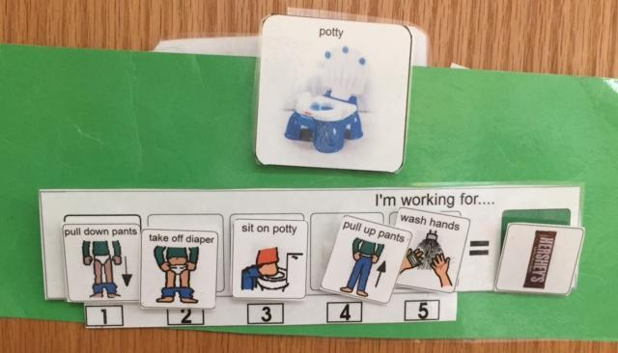  Link to video of child modeling steps of Video modeling Hand Washing  Hand Washing Data Sheet-Hand Washing | Overview of Toilet Training | EBIP  Picture Schedules for Daily Routines  CSEFEL Resources; Go to Module 3b “Tips and Ideas for Making Visuals to Support Young Children with Challenging Behavior”  Self-regulation- tips
Morning | Meal Time-  Breakfast | Adaptive(feeding)  Cognition  Communication  Fine Motor  Social | - Requesting choices  - Following verbal directions  - Sequencing  - Eating with utensils  - Transferring food and liquid between containers | How To: Teaching Requesting video  Table manners animated video  Prepare Breakfast Together a variety of recipes including visual supports. | CSEFEL Resources; click on “Become Independent with Daily Routines”  Video: How To: Providing Choices  Social Stories for Children on multiple topics
Morning | Getting Dressed | Adaptive(dressing)  Cognition  Communication | - Discrimination Sequencing  - Requesting attributes(warm weather clothes versus cooler weather)  - Eye-hand coordination  - Grasping  - Fasteners  - Sorting | Getting dress choice board or use actual garments  Getting dressed picture schedule  Link to PBS Kids Interactive Color Sort Game | Link to list of various social stories on the Head Start Center for Inclusion website  Center on the Social and Emotional Foundations for Early Learning modules and resources for parents on topics such as making connections, teaching routines, and challenging behavior
Morning | Independent Play/Toys | Across all domains | - Requesting a choice  - Engaging independently with materials in appropriate manner  - Cause and effect  - Eye hand coordination  - Bilateral motor coordination  - Understanding spatial relationships  - Grasping objects | 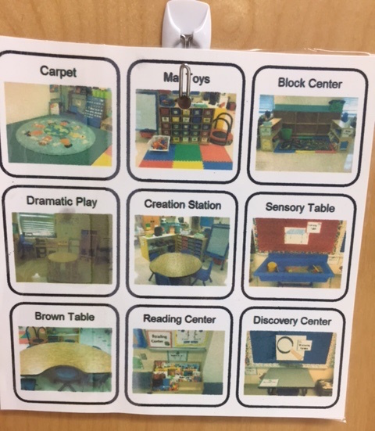  Example of a choice board with photos to select a play activity  Routine at home-playing Mr. Potato Head video | Activities for Families at Home; videos demonstrating embedding activities into daily routines for families.  Podcast 41: Transforming Challenging Behavior - It's Mindset Before Methods! showing how to transform challenging behaviors
Morning | Independent Play-Sensory experiences/  hands on exploration | Across all domains | - Completing inset/connecting puzzles or connecting toys | List of sensory play ideas
Morning | Independent Play- Screen time | Across all domains | - Eye hand coordination  - Following directions  - Concept development | PBS Kids, ABCya, Starfall provide interactive games that will allow a student to practice fine motor skills.
Morning | Independent Play-Books | Across all domains | - Early literacy skills  - Orientation of book, turning pages  - Fine motor skills | ECLCK article: Tips for Parents: Choosing Books for Infants and Toddlers  Literacy Every Day - Ready to Succeed; information on how to build literacy activities into daily routines  Parts of book video introducing young children to parts of a book.  Booktrust: Stories read aloud
Morning | Play with Others | Cognition, Communication, Fine motor, Gross motor, Social | - Develop social skills  - Develop positive relationships with peers  - Turn taking  - Sustains interactions with other | NAEYC article: Five Essentials to Meaningful Play with activities to make at home.  Play Games, Learn Math! Explore Numbers and Counting with Dot Card and Finger Games | Assistive Technology at Home: Easy Adaptations for Daily Living detailing ways to use low tech within all daily routines.
Afternoon | Meal Time- Lunch | Adaptive(feeding)  Cognition  Communication  Fine Motor  Social | - Requesting choices  - Following verbal directions  - Sequencing  - Eating with utensils  - Transferring food and liquid between containers | Picture example of a homemade choice board children can use when making choices  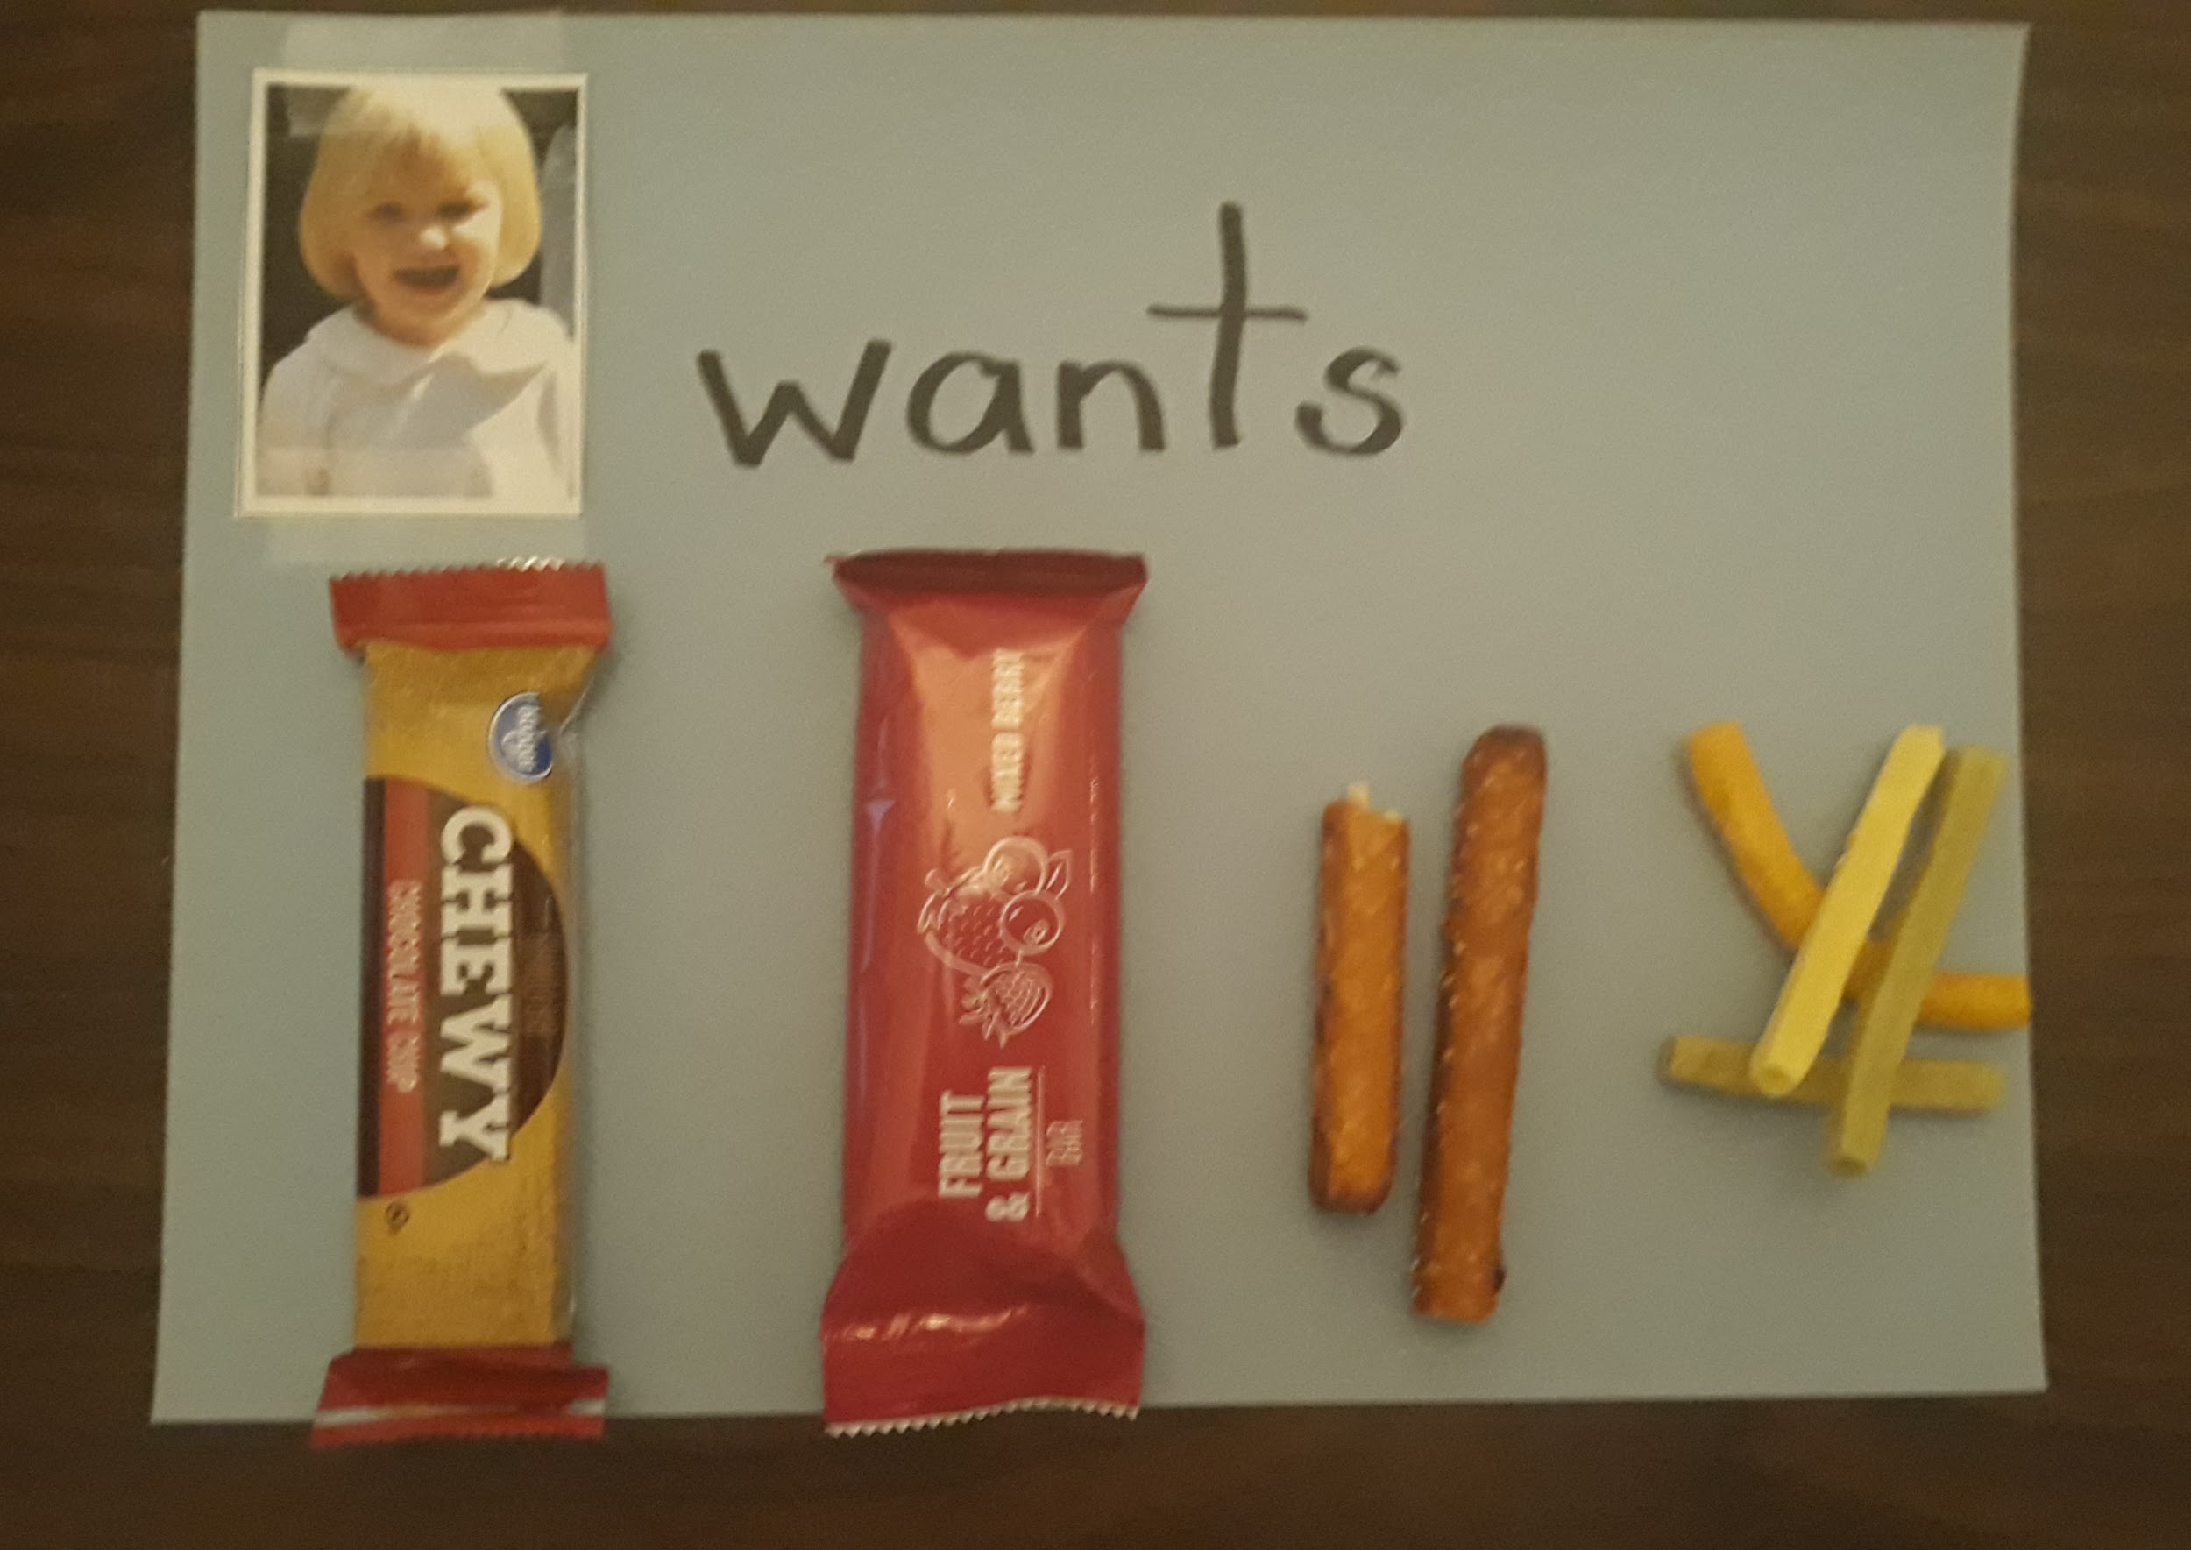
Afternoon | Outside Time | Gross Motor | - Eye hand, eye-foot coordination  - Jumping, walking skipping running  - Directional concepts ( up, down, over, around  - Balance  - Following movements  - Calming  *Choose activities to fit the needs and ability of the child.) | Obstacle Course: Go to“Activity 6: Build your own obstacle course”  Gross Motor Activity choice board  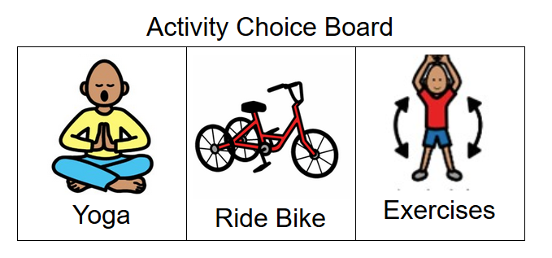  Learn to sign going outside video  Yoga video #1 which illustrates body movements to help children calm and focus  Yoga video #2
Afternoon | Rest Time
Afternoon | Independent Play: Music & Movement break | Cognition, Communication,  Social-Emotional | - Coordinate movements  - Imitating movements  - Follow directions  - Identify body parts  - Spatial relations (position of body parts) | Movement videos of the songs Head, Shoulders, Knees and Toes, Move and Freeze, and  Freeze Dance
Evening | Dinner | Adaptive  Cognition  Communication  Fine motor  Social-emotional | - Follow directions  - Spatial relations (position of objects and food)  - Group by size  - reciprocal communication | Video modeling how to set the table  Printable table setting placemat to provide a visual to assist a student with this task.
Evening | Getting Out | Adaptive, Cognition, Social-Emotional, Gross Motor | - Spatial relations (position of people and objects)  - Group by size  - Self-regulate  - Follow directions | Choice board of activities  Tar Heel Reader book library; search “Grocery Store”
Evening | Bedtime Routine:  Brushing Teeth | Adaptive, Cognition, Fine Motor, Communication, Social-Emotional | - Sequencing (ordering)  - Follow directions | Tooth brushing video modeling  Tooth Brush visual sequence  Picture example of a sequence strip to teach tooth brushing
Evening | Bedtime Routine: Storytime | Cognitive, Communication,  Fine Motor | - Ask and answer questions  - Make predictions  - Sequencing (ordering of events)  - Indicate choice | Tar Heel Shared Reader  Picture example of a homemade choice board children can use to pick a book  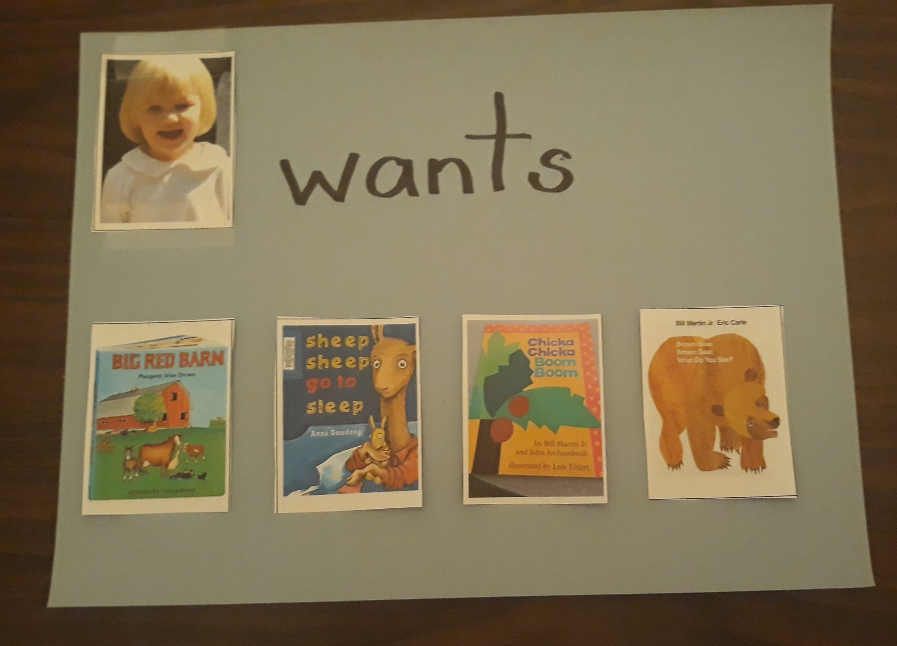
Evening | Transitions | Cognition, Communication,  Social-emotional | - Moving from one activity to the next independently  - Participating in preferred and non-preferred activities  - Concept of time | How To: Transitioning video on transitioning from activity to activity  TEACCH Tip#4 visual countdowns and time limits: tip sheet with photos for visual countdowns and time limits for activities-  NCPMI resource site: Search “Transition Visual Cards” available in English and Spanish  Link to Online Clock Countdown  Picture example of a homemade First/Then board  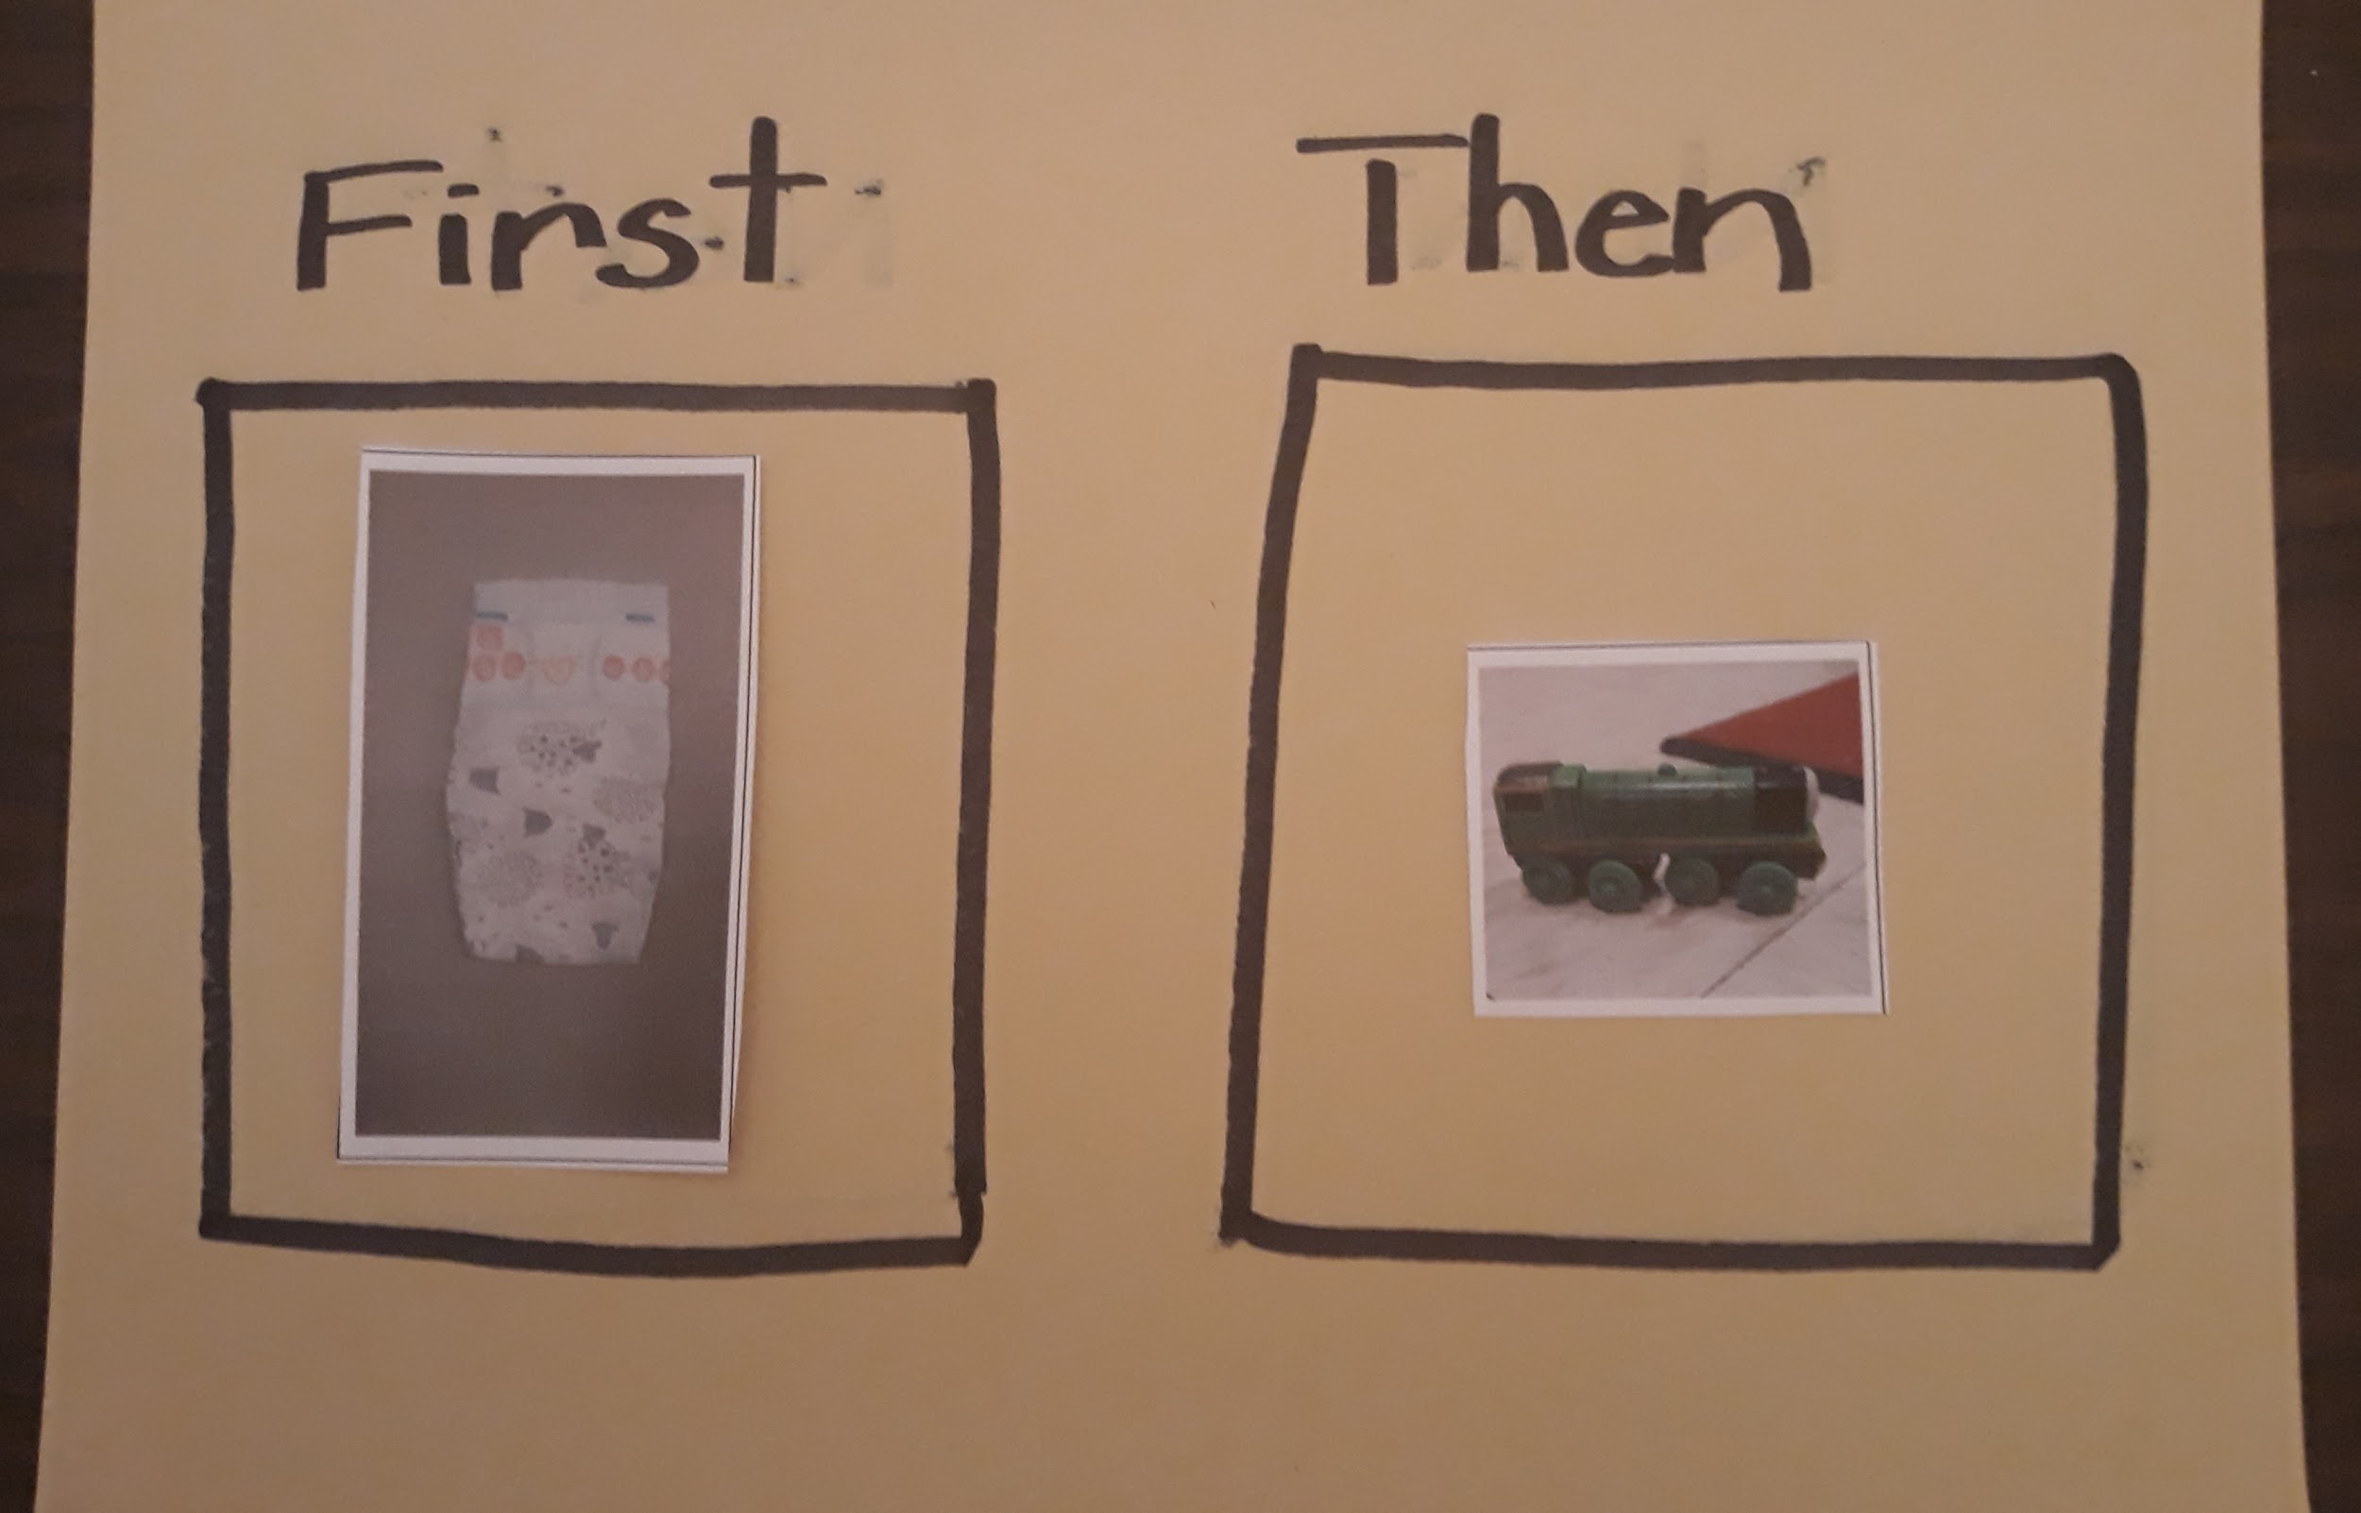
(back to
(back to top)

