Itinerant Early Childhood Special Education Communities of Learning

Resources for the Upcoming School Year
Many concepts, models, and resources were shared during your participation in the Itinerant Early Childhood Special Education (IECSE) Community of Learning. This document includes key information and tools for service delivery as you begin a new school year.

The IECSE Model
Three Components of the  IECSE Teacher’s Work |  | 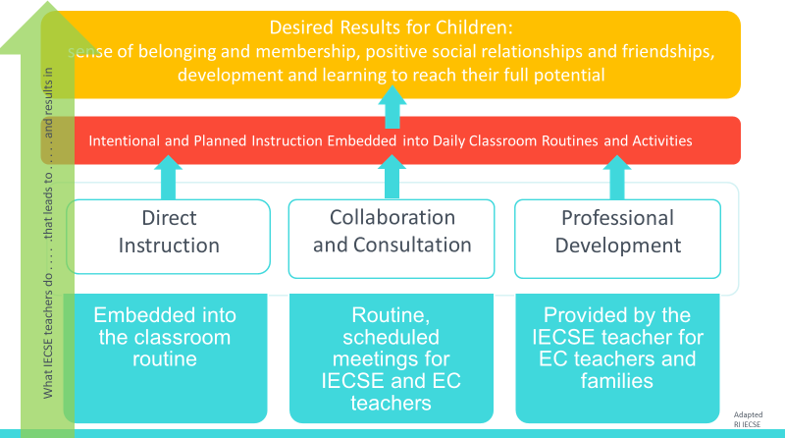 |  | This graphic depicts the work of the IECSE teacher. IECSE teachers provide direct instruction to preschoolers with IEPs, collaboration/consultation with early childhood partner teachers, and professional development for teachers and families. These efforts lead to a sense of belonging and membership, positive social relationships and friendships, and development and learning to enable children to reach their full potential.
The Triadic Model | 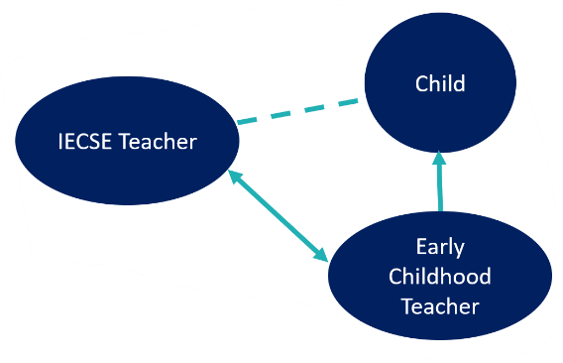 |  |  | This graphic of the Triadic Model portrays the interactions of the IECSE teacher, the Early childhood teacher, and the child with an IEP. “The IECSE teacher plans his or her visits with the intent to engage in reactive and proactive consultation and coaching strategies designed to transfer specific knowledge and skills to his or her partner. . . who then transfers them to the child.”  Dinnebeil & McInerney, 2011, pp.17-18
The Goal of the IECSE Model |  |  |  | The goal of the IECSE model is to provide multiple opportunities for learning, distributed throughout the day and week and embedded into the general early childhood classroom.

Getting Started with New Students and Early Childhood Partner Teachers
Introducing Yourself to a New Early Childhood Teacher |  | When meeting a new partner teacher, IECSE teachers introduce themselves with language that describes their role such as, “I am the itinerant early childhood special education teacher from Virginia City Schools. I am here to support you because you have a child with an IEP in your classroom” rather than “I am the itinerant early childhood special education teacher from Virginia City Schools. Jaxson is on my caseload.”
Early Childhood Educators Partnering to Meet a Child’s Special Needs | 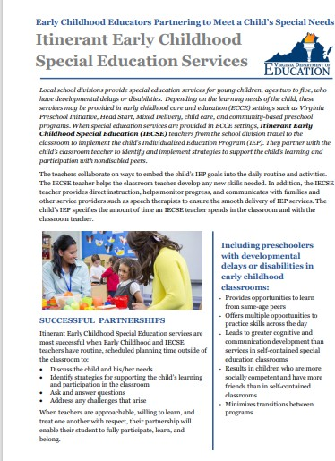 | This flyer introduces the IECSE model to general early childhood educators.

Meeting Your Child’s Special Needs in an Early Childhood Program | 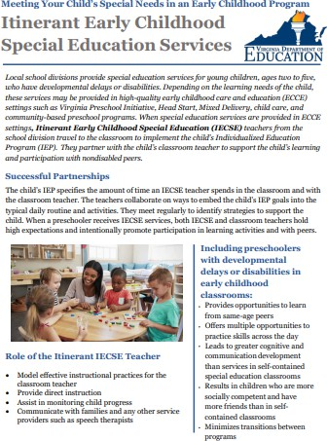 | This flyer provides an overview of the IECSE model for families of preschoolers eligible for special education services.
Itinerant Early Childhood Special Education Administrator Start-Up Steps for the New School Year | 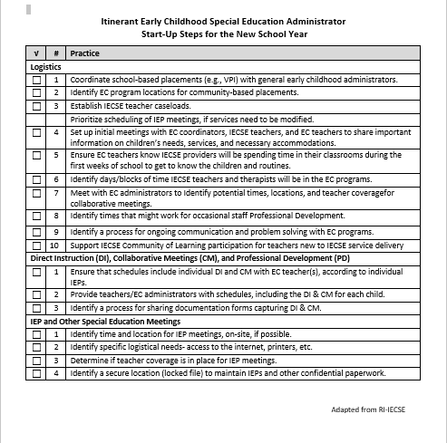 | This resource offers guidance for IECSE administrators. Beginning of the year tasks include logistics; support for direct instruction, collaborative meetings and professional development; and IEP and other special education meetings.

IECSE Caseload Management Form | 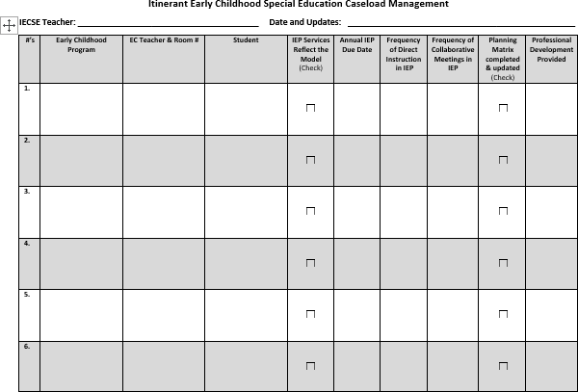 | The IECSE Caseload Management Form may be used to summarize information on all the students on an IECSE teacher’s caseload. It includes student and EC teacher names, frequency and types of services, matrix completion, IEP due dates, etc.
IECSE Planning and Documentation Form | 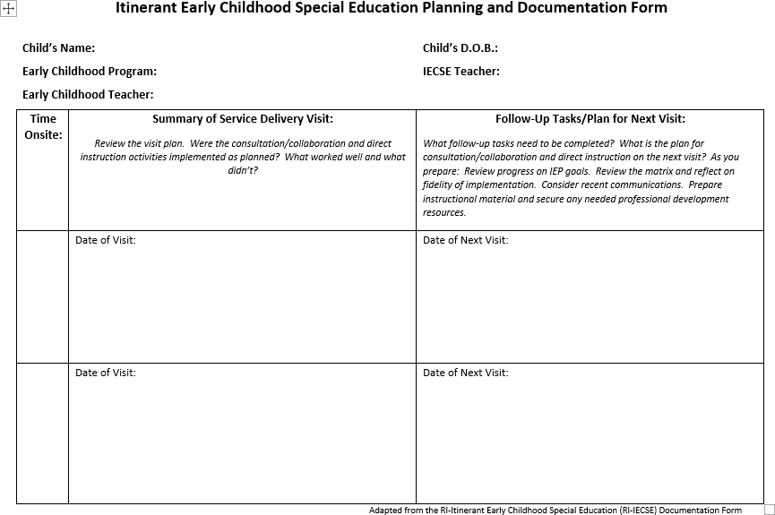 | The IECSE Planning and Documentation Form is a tool for IECSE teachers to document an onsite visit and plan for the next meeting. School divisions may choose to convert this document for electronic record keeping.

Tools for Gathering Information About the Child’s Placement and Goodness of Fit
Ecological Congruence Assessment for Classroom Activities and Routines | 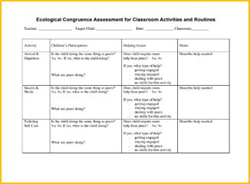 | The Ecological Congruence Assessment (ECA) documents the goodness of fit between a child with a delay/disability and their classroom environment. It moves through the instructional day comparing the engagement of the child with an IEP with children who are typically developing.  Information gathered through the ECA will contribute to the development of the Embedded Instruction Matrix.
Engagement, Independence, Social Relationships (EISR) | 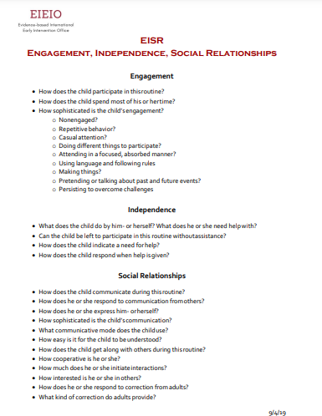 | The EISR is based on the Routines-Based Model and focuses on a child’s functional skills used to participate in home, school, and community routines.  Information gathered through the EISR will contribute to the development of the Embedded Instruction Matrix.

FACETS Identifying Classroom Routines and Activities | 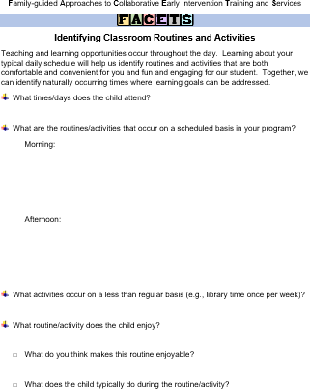 | FACETS Identifying Classroom Routines and Activities is a tool for IECSE teachers and their early childhood partner teachers to identify naturally occurring routines and activities when learning goals can be addressed.  Information gathered through FACETS will contribute to the development of the Embedded Instruction Matrix.
Inclusive Classroom Profile  IECSE CoL participants received an ICP form. | 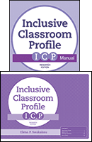 | The ICP is a structured observation rating scale to assess the quality of daily classroom practices that support preschool children with disabilities. It focuses only on children with IEPs and the individualized supports provided. It is designed to complement existing program quality measures such as CLASS.

Correlation between the Inclusive Classroom Profile (ICP) and PreK CLASS | 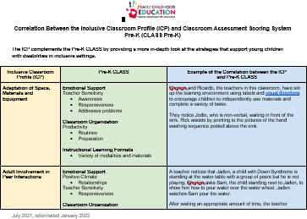 | The Inclusive Classroom Profile (ICP) complements the PreK CLASS by providing a more in-depth look at the strategies that support preschoolers with disabilities in inclusive settings. This document shares the correlation between ICP and CLASS areas, providing examples of what it looks like in the classroom.
Correlation between the Inclusive Classroom Profile (ICP) and Toddler CLASS | 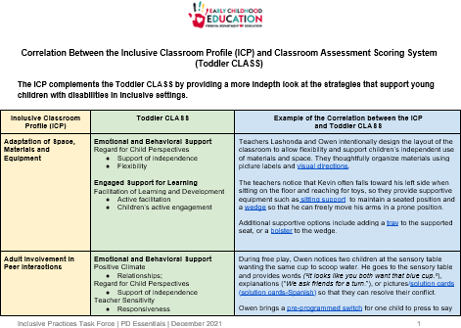 | The Inclusive Classroom Profile (ICP) complements the Toddler CLASS by providing a more in-depth look at the strategies that support toddlers with disabilities in inclusive settings. This document shares the correlation between ICP and CLASS areas, providing examples of what it looks like in the classroom.

Instructional Resources
Embedded Instruction Matrix Form | 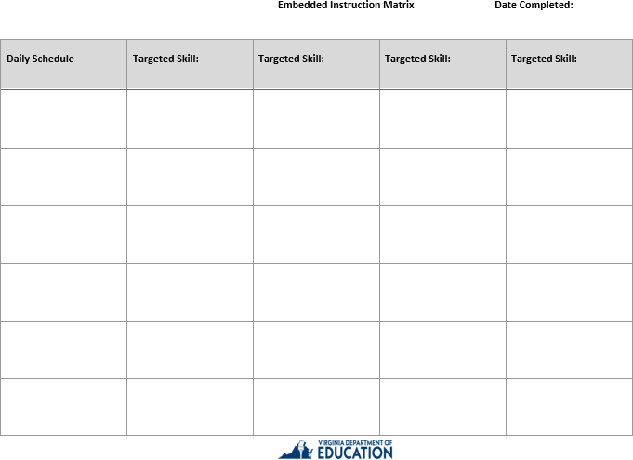 | The Embedded Instruction Matrix Form is a tool for IECSE and early childhood teachers to embed IEP goals and targeted skills throughout naturally occurring daily classroom routines and activities.
Building Blocks for Teaching Preschoolers with Special Needs  IECSE CoL participants received this book. | 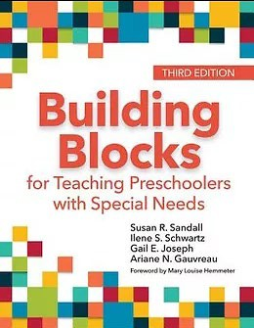 | This book by Sandall, Schwartz, Joseph, and Gauvreau (2019, 3rd. ed.) provides practical, evidence-based inclusion strategies including curriculum modifications, embedded learning opportunities, and child-focused instructional strategies.
Hoosier’s Rule |  | When collaborating with a partner teacher, ask four questions before suggesting. This ensures IECSE teachers have sufficient information to offer a reasonable suggestion.  Also, ask to suggest (e.g., What do you think would happen if . . .?’). This recognizes the expertise of the early childhood teacher and the fact that it is their classroom.

Improving Practices and Outcomes for Preschoolers Manual  (previously Inclusive Placement Opportunities for Preschoolers) | 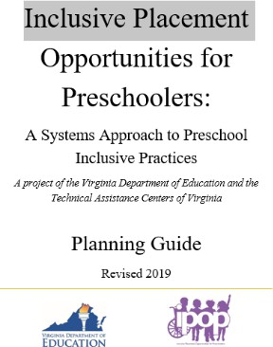 | This manual was developed by the Virginia Department of Education and the Training and Technical Assistance Centers to help local school divisions meet federal and state mandates that children with disabilities be educated in the Least Restrictive Environment (LRE). The manual contains 8 modules and extensive resources that provide critical information for understanding, building, supporting, and sustaining inclusive placement opportunities for young children with disabilities.
General Resources
Virginia Guidelines for Early Childhood Inclusion (revised 2023) | 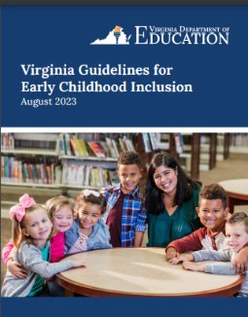 | This guidance document assists Virginia’s school divisions and early childhood communities in identifying, developing, and sustaining inclusive opportunities for children with disabilities within high-quality early childhood programs.
Regulations Governing Special Education Programs for Children with Disabilities in Virginia |  | The Regulations delineate the requirements for special education and related services for students with disabilities. They reflect Virginia and federal requirements.

Early Childhood Inclusion Class Size Information |  | This resource outlines requirements and regulations that impact the number of students with IEPs placed in a classroom as well as offers guidance for best practice. This resource should be used to plan and schedule for inclusive classes. This can include VPI, Head Start, Title 1, locally funded, Reverse Inclusion, and community based preschool programs.
Virginia Department of Education: Inclusion in Early Childhood Webpage |  | This webpage was developed by the Virginia Department of Education and is a compilation of several key resources related to inclusion in early childhood.
A Guide to Itinerant Early Childhood Special Education Services  IECSE CoL participants received this book. | 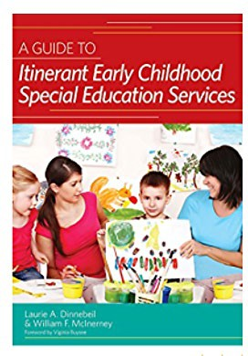 | This 2011 book by Dinnebeil & McInerney includes knowledge and guidance needed by IECSE teachers to integrate learning opportunities into daily routines and activities for preschoolers with IEPs in inclusive settings.
LEADS Website | 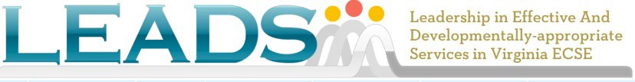 | The Leadership in Effective And Developmentally-appropriate Services (LEADS) in Early Childhood Special Education website provides resources and tools to support local ECSE programs.

Readiness Connections |  | Readiness Connections is the Virginia Department of Education’s weekly source of program updates for child care centers, family day homes, Head Start, VPI, and Early Childhood Special Education.
July 2025

