Virginia Indicator 6 Data
December 1, 2018
Indicator 6: Early Childhood Placement*
Indicator 6: Early Childhood Environment for Children with IEPs
- Target A – Regular early childhood program and receiving the majority of special education and related services in the regular education childhood program;
- Target B – Separate special education class, separate school, or residential facility
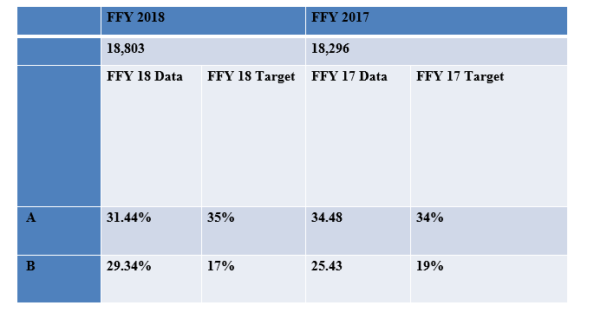
State Target for FFY 2017:
Target A: Greater or equal to 35%
Target B: Less than or equal to 17%
State Data for FFY 2018:
Target A: 31.44% (Did not meet Target, Slippage)
Target B: 29.34% (Did not meet Target, Slippage)
State Data for FFY 2017:
Target A: 34.48% (Met Target)
Target B: 25.43% (Did not meet Target)

*This is preliminary data and will be reviewed and confirmed by the Virginia Department of Education (VDOE) and Office of Special Education Programs.

Indicator 6a: Children 3-5 Attending and Receiving the Majority of Services in the Program, 2017-18
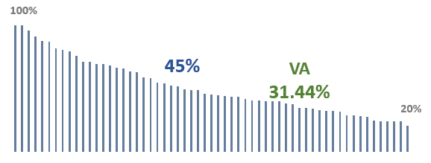
Each bar represents a State or Territory
Data rounded to whole numbers, 2 states unable to report due to questionable data quality

Indicator 6b: Children 3-5 Attending Special Ed Class, Separate School or Residential Program 2017-18

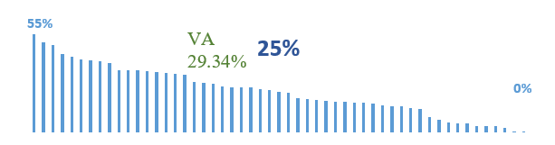

Each bar represents a State or Territory
Data rounded to whole numbers, 2 states unable to report due to questionable data quality

