Virginia Child Count Dec 2024*
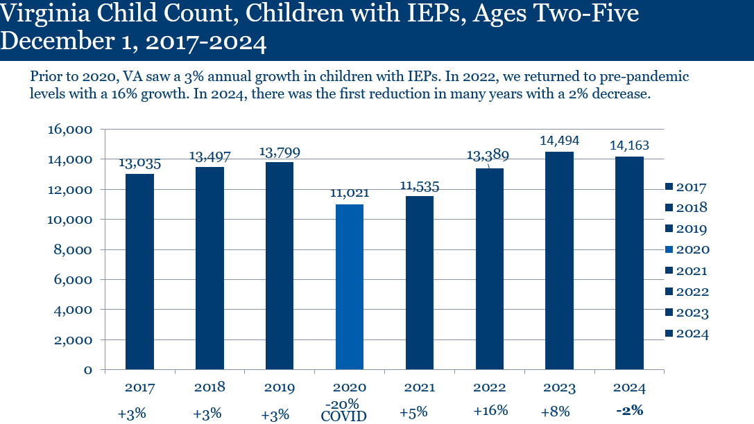
Children with IEPs, Ages 2-5
- In 2017, 13,035 children
- In 2018, 13,497 children
- In 2019, 13,799 children
- In 2020 (Covid-19), 11,021 children (2020 total decreased of 2,778, 20%)
- In 2021, 11,535 children (2021 total decrease of 2,264 from 2019, 16%)*
*Prior years were increasing by 3%
- In 2022, 13,389 children (16% increase from 2021)
- In 2023, 14,494 children (8% increase from 2022)
- In 2024, 14,163 children (2% decrease from 2023)

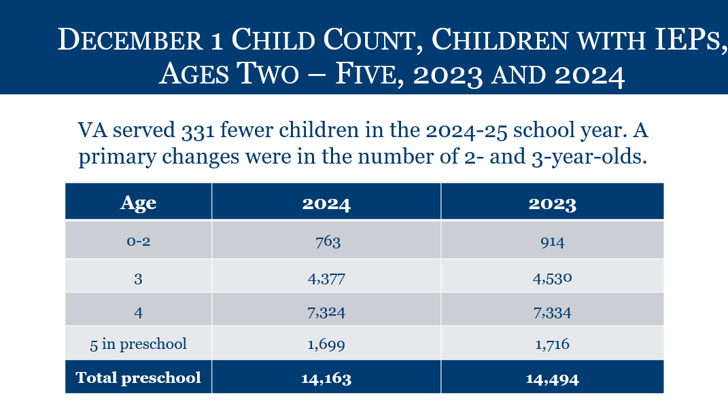
Children with IEPs, by Age
- Ages 0-2: 763 children with IEPs
- Age 3: 4,377 children with IEPs
- Age 4: 7,324 children with IEPs
- Age 5: 1,699 children with IEPs
- TOTAL PRESCHOOL: 14,163 children with IEPs

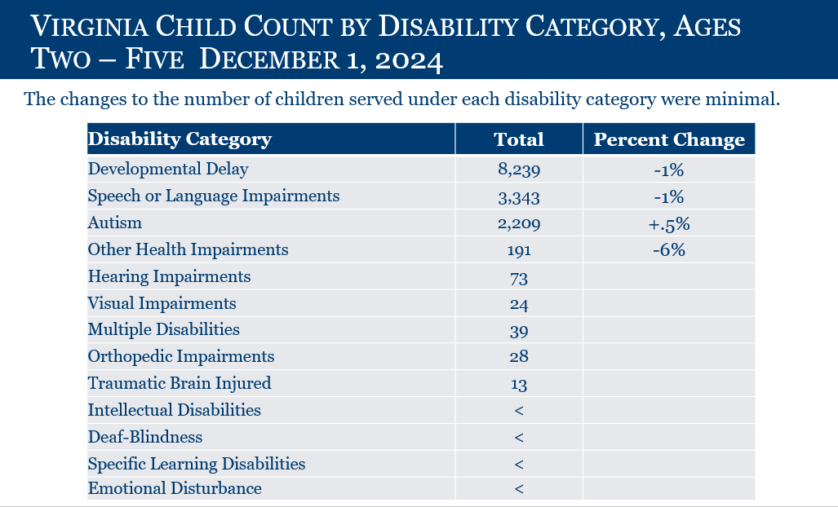

2-5 Year Olds (TOTAL: 14,163)
Developmental Delay: 8,239 (-1%)
Speech Language Impairment: 3,343 (-1%)
Autism: 2,209 (+.5%)
Other Health Impairments: 191 (-6%)
Hearing Impairments: 73
Visual Impairment: 24
Multiple Disabilities: 39
Orthopedic Impairment: 28
Traumatic Brain Injured: 13
Intellectual Disability: less than 11
Deaf-Blindness: less than 11
Specific Learning Disability: less than 11
Emotional Disturbance: less than 11

*This is preliminary data and will be reviewed and confirmed by the Virginia Department of Education (VDOE) and Office of Special Education Programs.

