Virginia Child Count Dec 2021*
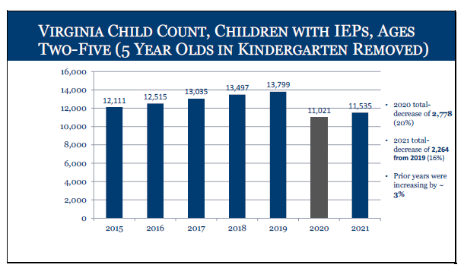
Children with IEPs, Ages 2-5 (5 year olds in Kindergarten Removed)
- In 2015, 12,111 children
- In 2016, 12,515 children
- In 2017, 13,035 children
- In 2018, 13,497 children
- In 2019, 13,799 children
- In 2020 (Covid-19), 11,021 children (2020 total decreased of 2, 778, 20%)
- In 2021, 11,535 children (2021 total decrease of 2,264 from 2019, 16%)*
*Prior years were increasing by 3%
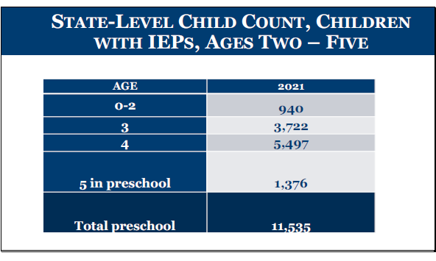
Children with IEPs, by Age
- Ages 0-2: 940 children with IEPs
- Age 3: 3,722 children with IEPs
- Age 4: 5,497 children with IEPs
- Age 5: 1,376 children with IEPs
- TOTAL PRESCHOOL: 11,535 children with IEPs
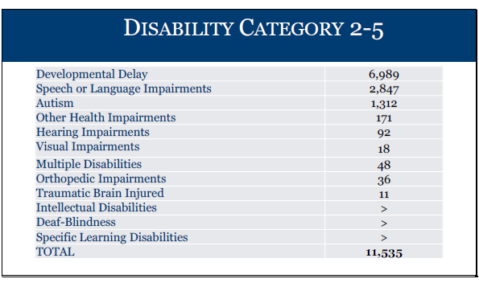

2-5 Year Olds (TOTAL: 11,535)
Developmental Delay: 6,989
Speech Language Impairment: 2,847
Autism: 1,312
Other Health Impairments: 171
Hearing Impairments: 92
Visual Impairment: 18
Multiple Disabilities: 48
Orthopedic Impairment: 36
Traumatic Brain Injured: 11
Intellectual Disability: Number too low to report
Deaf-Blindness: Number too low to report
Specific Learning Disability: Number too low to report

*This is preliminary data and will be reviewed and confirmed by the Virginia Department of Education (VDOE) and Office of Special Education Programs.

