Virginia Child Count, 2018*
Children with IEPs, Ages Two-Five
- In 2013, approximately 17,250 children
- In 2014, approximately 17,350 children
- In 2015, approximately 17,600 children
- In 2016, approximately 18,500 children
- In 2017, approximately 19,200 children
- In 2018, approximately 19,800 children- An increase of 620 children from 2017
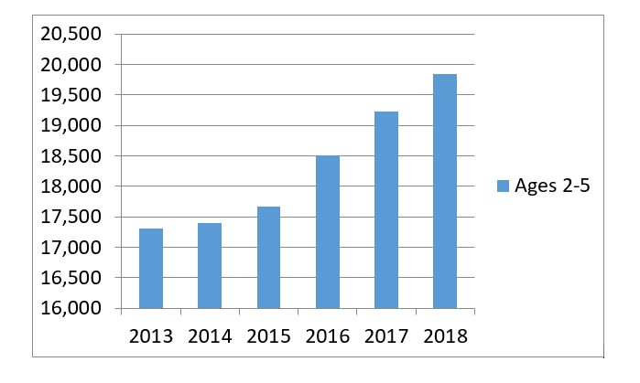
Children with IEPs, by Age
- Ages 0-2: 1,038 children with IEPs (an increase of 110 children (15%) from 2017)
- Age 3: 4,309 children with IEPs
- Age 4: 6,485 children with IEPs
- Age 5: 8,012 children with IEPs
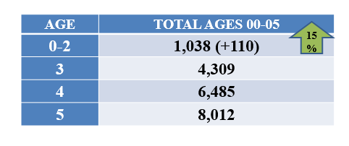
*This is preliminary data and will be reviewed and confirmed by the Virginia Department of Education (VDOE) and Office of Special Education Programs.

