Virginia Child Count Dec 2025*

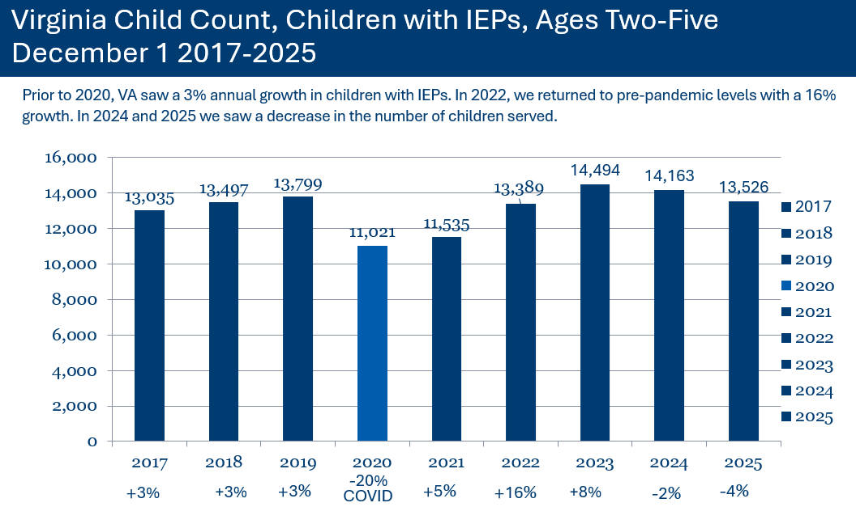

Children with IEPs, Ages 2-5
- In 2017, 13,035 children
- In 2018, 13,497 children
- In 2019, 13,799 children
- In 2020 (Covid-19), 11,021 children (2020 total decreased of 2,778, 20%)
- In 2021, 11,535 children (2021 total decrease of 2,264 from 2019, 16%)*
  - *Prior years were increasing by 3%
- In 2022, 13,389 children (16% increase from 2021)
- In 2023, 14,494 children (8% increase from 2022)
- In 2024, 14,163 children (2% decrease from 2023)
- In 2025, 13,526 children (4% decrease from 2024

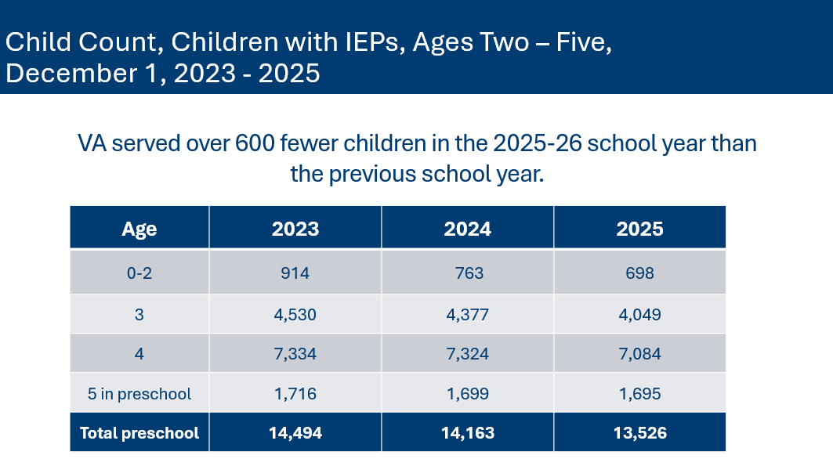
Children with IEPs, by Age
- Ages 0-2: 698 children with IEPs
- Age 3: 4,049 children with IEPs
- Age 4: 7,084 children with IEPs
- Age 5: 1,695 children with IEPs
- TOTAL PRESCHOOL: 13,526 children with IEPs

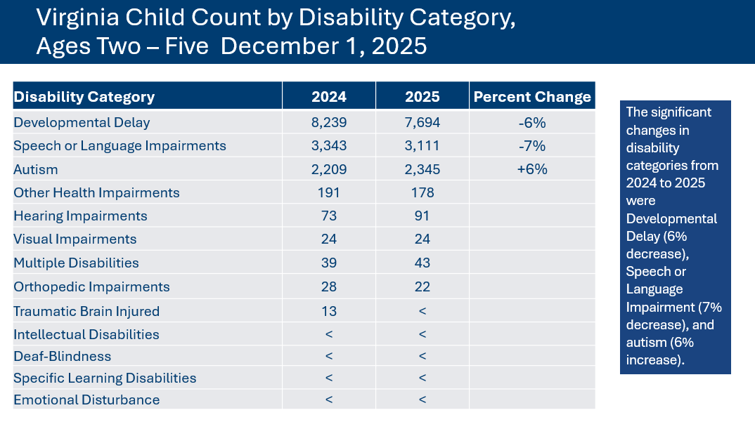
2-5 Year Olds (TOTAL: 13,526)
- Developmental Delay: 7,694 (-6%)
- Speech Language Impairment: 3,111 (-7%)
- Autism: 2,345 (+ 6%)
- Other Health Impairments: 178
- Hearing Impairments: 91
- Visual Impairment: 24
- Multiple Disabilities: 43
- Orthopedic Impairment: 22
- Traumatic Brain Injured: less than 11
- Intellectual Disability: less than 11
- Deaf-Blindness: less than 11
- Specific Learning Disability: less than 11
- Emotional Disturbance: less than 11

*This is preliminary data and will be reviewed and confirmed by the Virginia Department of Education (VDOE) and Office of Special Education Programs.

