
Meeting Your Child’s Special Needs in an Early Childhood Program

Itinerant Early Childhood Special Education Services

Local school divisions provide special education services for young children, ages two to five, who have developmental delays or disabilities. Depending on the learning needs of the child, these services may be provided in high-quality early childhood care and education (ECCE) settings such as Virginia Preschool Initiative, Head Start, Mixed Delivery, child care, and community-based preschool programs. When special education services are provided in ECCE settings, Itinerant Early Childhood Special Education (IECSE) teachers from the school division travel to the classroom to implement the child’s Individualized Education Program (IEP). They partner with the child’s classroom teacher to support the child’s learning and participation with nondisabled peers.

Successful Partnerships
The child’s IEP specifies the amount of time an IECSE teacher spends in the classroom and with the classroom teacher. The teachers collaborate on ways to embed the child’s IEP goals into the typical daily routine and activities. They meet regularly to identify strategies to support the child. When a preschooler receives IECSE services, both IECSE and classroom teachers hold high expectations and intentionally promote participation in learning activities and with peers.

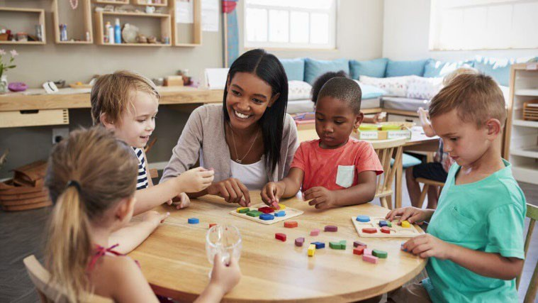
Including preschoolers with developmental delays or disabilities in early childhood classrooms:
- Provides opportunities to learn from same-age peers
- Offers multiple opportunities to practice skills across the day
- Leads to greater cognitive and

Role of the Itinerant IECSE Teacher
- Model effective instructional practices for the classroom teacher
- Provide direct instruction
- Assist in monitoring child progress
- Communicate with families and any other service providers such as speech therapists
communication development than services in self-contained special education classrooms
- Results in children who are more socially competent and have more friends than in self-contained classrooms
- Minimizes transitions between programs

