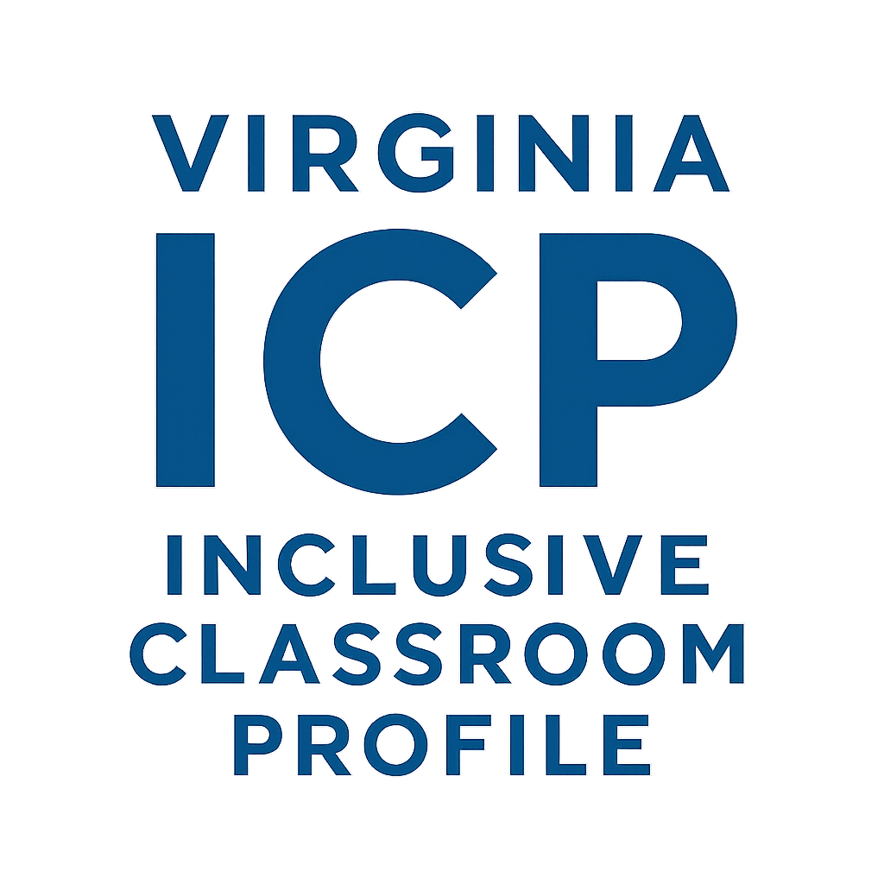

Inclusive Classroom Profile (ICP), Virginia Reliable Observer

Description and Training Application

Cohort 4

This document is intended for school division/program leaders interested in becoming reliable and proficient users of the Inclusive Classroom Profile (ICP) to improve the quality of inclusive practices. It aims to provide an overview of the ICP and its benefits and describe a process for interested school division/program leaders to become reliable users of the tool at a low cost. This document will help determine if the ICP tool and training make sense for your team.

As a reminder, all publicly funded early childhood programs must participate in VQB5. VQB5 requires two local CLASS observations, one in fall and one in spring, and participation in external Classroom Assessment Scoring System (CLASS) observations. Further information can be found in the VQB5 Resources on the Virginia Department of Education (VDOE) website. The ICP may be used to supplement CLASS observations and may not be used as a replacement. As a result, any individual interested in becoming an ICP Virginia Reliable Observer must first be certified on the PreK or Toddler CLASS measure.

The Inclusive Classroom Profile

The ICP, authored by Dr. Elena Soukakou, is a structured observation rating scale designed to assess the quality of classroom practices that support the developmental needs of children aged 2½ to 5 years with Individualized Education Programs (IEPs) in inclusive early childhood settings. Ratings on the ICP items indicate the extent to which program staff intentionally adapt the classroom’s environment, activities, and instructional support to encourage children’s active participation in the group. When used in conjunction with other system supports, including CLASS observations, a pilot in Virginia classrooms found the ICP to be a powerful tool for improving inclusive practices.

The Virginia Reliable Observer
To increase the number of reliable users of the ICP, Virginia has developed a training process for early childhood school division and program leaders. The ICP is to be implemented by a trained observer, such as a technical assistance professional, administrator, master teacher, or coach. The process is offered to interested school division/program leaders so they may complete observations across inclusive classrooms.

Before becoming an ICP Virginia Reliable Observer, it is important to understand the ICP Virginia Reliable Observer Training process and how the ICP will fit into your division/program-wide plans. This document provides information about the process, including:
- Benefits of the ICP as a supplement to the required VQB5 system,
- Role of an ICP Virginia Reliable Observer,
- Description of the ICP Virginia Reliable Observer Training process,
- A readiness guide to confirm your school division/program is ready to adopt the ICP,
- Roles and Responsibilities for the Training and Technical Assistance Centers (T/TAC) and school divisions/programs,
- Funding requirements, and
- The ICP Virginia Reliable Observer Training Application.

What are the benefits of using the ICP in a school division/program?
While VQB5 utilizes the CLASS to establish shared expectations for measuring quality and supporting teachers in all publicly funded birth-to-five programs, the ICP offers an in-depth examination of the strategies that specifically support young children with disabilities in inclusive settings. The ICP observation process provides rich information and insights needed to:
- Assess a program’s current inclusive practices,
- Establish a baseline for measuring future progress in inclusive programming,
- Apply recommended inclusive practices for young children,
- Guide quality inclusion improvement efforts by linking assessment data with instructional decision-making, and
- Tailor professional development to teachers’ specific needs in supporting children with disabilities.

Virginia developed a document outlining the correlation between the ICP and CLASS to better understand the relationship between both instruments. It provides examples of what the correlation may look like in the classroom.

What is the role of an ICP Virginia Reliable Observer?
The ICP Virginia Reliable Observer will be a reliable and proficient user of the ICP and will implement the ICP in classrooms in their own division or program. Observers will use the observations to improve quality in inclusive classrooms by providing teachers individualized feedback and delivering professional development.

For those interested in using the ICP for research purposes or who want more intensive training, Brookes Publishing offers Brookes On Location. It is a five-day reliability training that consists of a face-to-face overview of the ICP administration and scoring procedures, and four classroom observations with an ICP-qualified trainer to help users meet reliability proficiency. This training is fee-based and may require out-of-state travel.

What is the ICP Virginia Reliable Observer Training process?

The Virginia Reliable Observer Training process has little financial cost and utilizes Virginia’s current resources, allowing school divisions/programs to use the ICP without the additional time and money required to complete the training provided by Brookes Publishing Company. A Virginia Reliable Trainer from one of VDOE’s T/TACs provides training in a Virginia early childhood classroom within or near the trainee’s school division or program.

The ICP Virginia Reliable Observer Training process includes:
- One full-day overview of the ICP administration and scoring procedures, and
- Two full days of in-person classroom observations, scoring, and debriefing sessions with a qualified Virginia Reliable Trainer.

This process is designed to help participants meet reliability proficiency before observing independently. If proficiency is not demonstrated during the two days, additional time will be added as needed.

How do I determine if Virginia ICP Reliability is the right fit for my division/program?

There are several factors for division/program leaders to consider. To learn more about the ICP, view this short video: Introduction to the Inclusive Classroom Profile.

The next step is to discuss readiness with administrators in your division/program. If desired, a T/TAC representative can assist in this discussion to ensure the initiative is right for your program and at this time. Be sure to consider these readiness questions when making your decision.

- Observers: Who are the people who will participate in the Virginia Reliable Observer Training? What time will they be given to attend training and complete observations?
- Leadership Commitment: Does the leadership team (including Regular Early Childhood Programs) support the ICP training and its use?
- Implementation: Who will complete the observations? How will observations be completed (e.g., a subset of classrooms, all classrooms)? How will CLASS and ICP observations be completed?
- Coaching/Professional Development Plan: How will teachers be prepared for observations? How will teachers be provided feedback following observations? How will support be provided to teachers following the observations? How will the ICP be proactively incorporated into the division/program professional development plan?
- Sustainability: How will the ICP reliable observer use the tool for future observations (time, resources)?

If your team determines the Virginia Observer Reliability Training process is right for your division/program, review the responsibilities below and complete the Virginia Reliable Observer Training Application with your team. All individuals participating in the Virginia Reliability Training process and conducting ICP observations must be reliable in the CLASS for the observed age group (Toddler for children aged 15-36 months or Pre-K for children aged 3-5 years).

What does our school division/program need to know before engaging in Virginia ICP Observer Reliability?

ICP Virginia Reliable Observer Training is provided annually to a cohort of interested individuals. Up to three individuals from a school division/program may participate. Trainers will strive to group new observers based on location/region to minimize travel. School divisions/programs are to provide financial support for travel and lodging if necessary.

Each individual is to complete the full training, which consists of a full-day overview and two days of classroom observations, scoring, and debriefing sessions. New observers will be considered reliable when they achieve 80% reliability (codes fall within one point of a Virginia Reliable T/TAC Trainer) across two observations with the T/TAC trainer.

Following ICP Training, the division/program will:
- Partner with their T/TAC to develop an action plan for year 2 that details how the ICP will be utilized within their division/program.
- Develop a sustainability plan with support from T/TAC for the school division to ensure continued use of the ICP.
- Share deidentified data from ICP observations completed with the VDOE to support continued improvement of the VA Reliability Training program and identify state-wide strengths and areas for growth to guide T/TACs' work (see section on Data below for more information.)
- With the assistance of T/TAC, complete an observation of the following school year in the same classrooms if possible.
- To maintain Virginia Reliability, complete calibration observations after three years. Calibration consists of the ICP Virginia Reliable Observer observing and coding with a Virginia Reliable T/TAC member, ensuring inter-rater reliability is again met, and proficiency is demonstrated.
- Participate in an annual Virginia ICP Reliable Observers Virtual Meeting each winter. This meeting provides an overview of practices and updates on the ICP instrument.
- Attend, when possible, quarterly Office Hours provided by the TTACs. The Office Hours provide opportunities for Virginia Reliable Observers to connect and learn from one another.

Responsibilities
The chart below defines the school division/program and T/TAC responsibilities for the Virginia Reliability Training Application.

The school division/program will: | T/TAC will:
Designate up to 3 people already PreK or Toddler CLASS certified to become Virginia Reliable on the ICP.  Trainee(s) will participate in a full-day training on the ICP. Dates will be determined collaboratively with T/TAC.  Trainee(s) will devote 2 full days to classroom observations, scoring, and debriefing sessions. Dates will be determined collaboratively with T/TAC.  Assist T/TAC in organizing 2 classroom observations, interview/document reviews, and debriefing sessions.  - Designate two classrooms with at least two children with IEPs to be observed and coordinate with the teacher(s).  - Provide time for teachers to participate in a brief (15-minute) interview/document review.  - Locate a quiet place for scoring and debriefing sessions. | Select applicants from the submitted applications to participate in the training process based on a scoring rubric.  Provide a training overview of the ICP and facilitate 2 days of in-person classroom observations, scoring, and debriefing sessions with cohort members.  Procure materials required for training.  Assist the school division/program in scheduling two classroom observations, interview/document reviews, and debriefing sessions.
After training is completed, the school division/program will: | After training is completed, the T/TAC will:
In collaboration with T/TAC, develop an action and sustainability plan for implementation of the ICP.  Participate in annual VA ICP Reliable Observers Virtual meetings and optional ICP Office Hours coordinated by T/TACs.  Share deidentified data with the VDOE to support continued improvement of the VA Reliability Training program.  Participate in calibration after three years with a Virginia Reliable T/TAC Trainer to check for scoring accuracy and consistency. | Support the division/program in developing an action plan and sustainability plan..  Coordinate annual virtual ICP reliability meetings and office hours (virtual).  Assist the division/program in conducting 2 follow-up observations in Fall 2026 to provide to VDOE as deidentified data for continued improvement.  Organize and facilitate triennial calibration training.

How will ICP data be used and shared?

To evaluate the effectiveness of the Virginia ICP Reliability Training program, divisions/programs are asked to share deidentified ICP data with the VDOE.
- “Deidentified data” means that identifying information connected to the teacher and division will be removed, ensuring anonymity. Data received will be aggregated to evaluate the overall impact of the ICP in Virginia.
- Scores from two classroom observations are to be shared:
  - Observations completed during reliability training (Time 1).
  - Observations completed with the assistance of T/TAC the following school year (Time 2).
- Other data may be shared, but is not required.

Funding the ICP Virginia Reliable Observer Training

Virginia Reliability is a low-cost option to increase the number of reliable ICP observers in Virginia. Costs are shared between the school division/program and the T/TACs. The following table outlines cost responsibilities.

The school division/program will: | T/TAC will:
Fund travel to participate in training activities, including lodging if needed.  Purchase ICP materials to use the ICP in the school division/program once training is completed. | Provide training materials (ICP protocols, manuals, and other materials needed). This will include an ICP manual and 5 forms (~$70).  Pay for travel for the T/TAC trainer, including lodging as needed.  Provide classroom materials to teachers who open their classrooms for observations (~$70 in classroom materials).

Application

Applications are now being accepted for Cohort 4. Training is to begin early in 2027. Please complete the application form at https://form.jotform.com/232925497975071 by November 17th, 2026. If you have questions, please contact Allie Morris (amorri31@gmu.edu).

