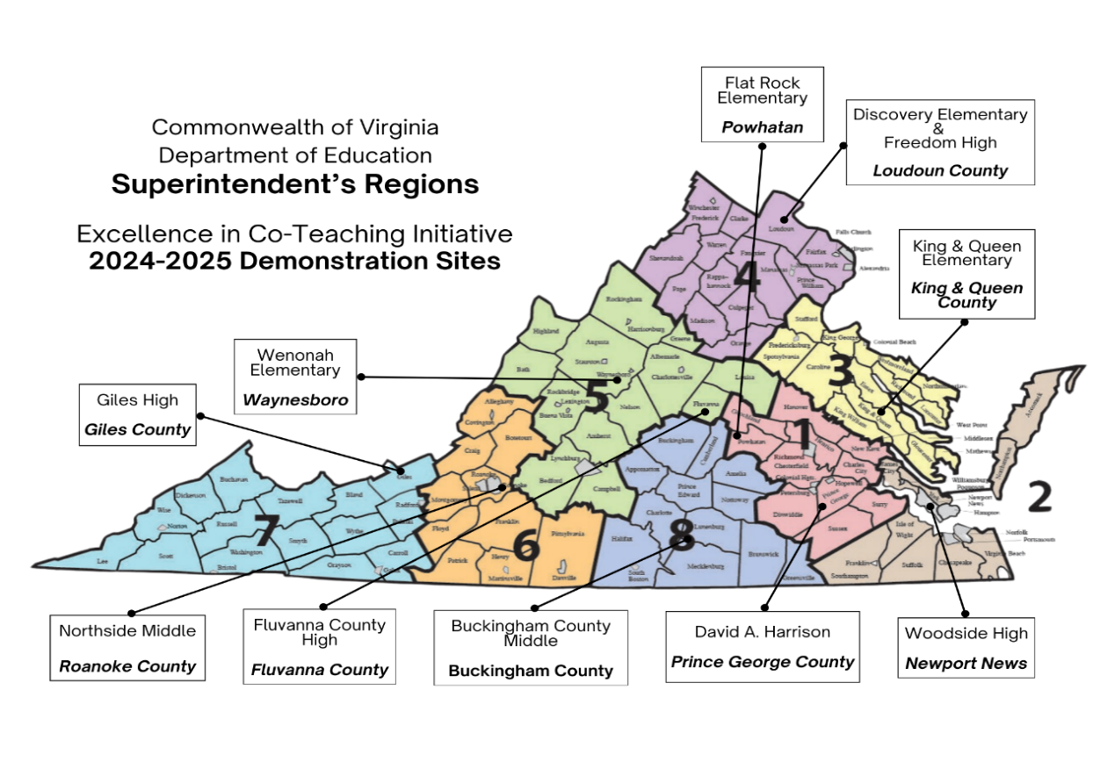

| **Region** | **Division & School** (Returning Teams/Mentors in Blue) | **General Educator**  **Special Educator** | **Principal** | **TTAC Facilitator** |
| --- | --- | --- | --- | --- |
| 1 | *Prince George County*  **David A. Harrison**  **Grade 2** | **Jessica Alderman**  jalderman@pgs.k12.va.us  **Candace Adair**  cadair@pgs.k12.va.us | **Christopher Scruggs**  cscruggs@pgs.k12.va.us | ***VCU***  **Mary Addeo**  mjaddeo@vcu.edu |
| 1 | *Powhatan County*  **Flat Rock Elementary**  **Grade 1** | **Lauren Ayers**  lauren.ayers@powhatan.k12.va.us  **Ebony Fleming**  ebony.fleming@powhatan.k12.va.us | **Isabella Worrell**  isabella.worrell@powhatan.k12.va.us | ***VCU***  **Mary Addeo**  mjaddeo@vcu.edu |
| 2 | *Newport News*  **Woodside High**  **English 11** | **Alexander Riccio**  alexander.riccio@nn.k12.va.us  **Courtney Privette**  courtney.privette@nn.k12.va.us | **Mary Hardesty**  mary.hardesty@nn.k12.va.us | ***WM***  **Shelley Littleton** sblittleton@wm.edu  **Jason Betzner** jpbetzner@wm.edu |
| 3 | *King and Queen County*  **King and Queen Elem.**  **Grade 5**  **Math** | **Rachelle Pohlman**  rpohlman@kqps.net  **Kelly Harvey**  kharvey@kqps.net | **Mack Harvey**  mharvey@kqps.net | ***WM***  **Shelley Littleton** sblittleton@wm.edu  **Jason Betzner** jpbetzner@wm.edu |
| 4 | *Loudoun County*  **Discovery Elementary**  **Grade 3** | **Michelle Warner**  michelle.warner@lcps.org  **Eric Nolle**  Eric.Nolle@lcps.org | **Christopher Painter**  Christopher.Painter@lcps.org | ***GMU***  **Melissa Gunter**  mgunter2@gmu.edu |
| 4 | *Loudoun County*  **Freedom High**  **Algebra 2** | **Sara Turner**  sara.turner@lcps.org  **Michael Albert**  michael.albert@lcps.org | **Neelum Chaudhry**  neelum.chaudhry@lcps.org | ***GMU***  **Melissa Gunter**  mgunter2@gmu.edu |
| 5 | *Fluvanna County*  **Fluvanna County High**  **Algebra 1** | **Amanda Fisher**  afisher@apps.fluco.org  **Jennifer Goodwin**  jgoodwin@apps.fluco.org | **Margo Bruce**  mbruce@apps.fluco.org | ***JMU***  **Jillian Shifflett**  shiffljm@jmu.edu |
| 5 | *Waynesboro*  **Wenonah Elementary**  **Grade 3**  **Math & Reading** | **Nicole Mickens**  nmickens@waynesboro.k12.va.us  **Taylor Rose**  trose@waynesboro.k12.va.us | **Abby Aery**  aarey@waynesboro.k12.va.us | ***JMU***  **Jillian Shifflett**  shiffljm@jmu.edu |
| 6 | *Roanoke County*  **Northside Middle**  **Math 8** | **Amber Benson**  abenson@rcps.us  **Ruby Voss**  rvoss@rcps.us | **Dr. Paul Lineburg**  plineburg@rcs.k12.va.us | ***RU***  **Suzanne Graham**  s-graham@radford.edu  **Keli Bradbury**  ktbradbury@ruttac.org |
| 7 | *Giles County*  **Giles High**  **Grade 9**  **Algebra 1** | **Katherine Wright**  kwright@gilesk12.net  **Mandy Seeberger**  mseeberger@gilesk12.net | **Shelley Boggess**  sboggess@gilesk12.net | ***VT***  **Kitty Wade** kittywms@vt.edu  **Sue Schulz** suschulz@vt.edu  **Dana McCaleb** dmccaleb@vt.edu  **Whitney Miller** whm2378@vt.edu |
| 8 | *Buckingham County*  **Buckingham County Middle**  **Grade 8 English** | **Shawn Stinson**  sstinson@bcpschools.org  **Lynn Scruggs**  lscruggs@bcpschools.org | **Dr. Jeffrey Garrett** jgarrett@bcpschools.org | ***VCU***  **Leslie Murphy Brown** lmmurphybrown@vcu.edu |